C H A P T E R 8

Secondary Windows
The chapter covers the common types of secondary windows, such as property sheets, dialog boxes, palette windows, and message boxes. Their usage determines their behavior.

Characteristics of Secondary Windows
Secondary windows differ from primary windows in their appearance and operations. For example, secondary windows do not appear on the task bar. Secondary windows gather or display supplemental information which is often related to the objects that appear in a primary window.

Appearance and Behavior
A secondary window includes a title bar and frame; a user can move it by dragging its title bar. However, a secondary window does not include Maximize and Minimize buttons, because these sizing operations typically do not apply to a secondary window. A Close button may be included to dismiss the window. The title text is a label that describes the purpose of the window; the content of the label depends on the use of the window. Do not include icons in the title bar. Figure 8.1 shows a secondary window.

A secondary window may also include a What's This? button in its title bar. For more information about this form of contextual Help information, see Chapter 12, "User Assistance."

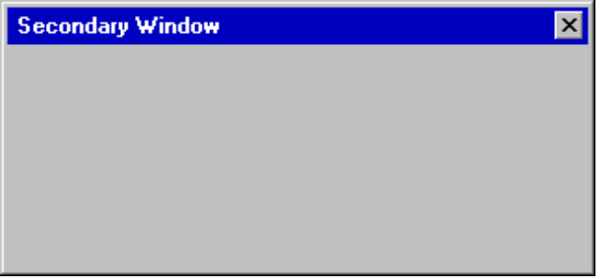

Figure 8.1 A Secondary Window.

A user can access a pop-up menu for the window using the same interaction techniques as primary windows.

Interaction with Other Windows
Secondary windows that result from a command executed within a primary window depend on the state of the primary window; that is, when the primary window is closed or minimized, the secondary windows are closed or hidden as well. When the user reopens or restores the primary window, your software should restore the secondary windows to their former positions and states. However, if opening a secondary window is the result of an action outside of the object's primary window; for example, if the user executes the Properties command on an icon in a folder or on the desktop, then the property sheet window is independent and appears as a peer with any primary windows, though it does not appear in the task bar.

Opening or switching to a secondary window activates it and deactivates any other windows. With the mouse or pen, the user can activate a secondary window in the same way as a primary window. With the keyboard, the alt+f6 key combination switches between a secondary window and its primary window, or other peer secondary windows that are related to its primary window.

When activating the primary window and bringing it to the top of the Z-order, bring all of its dependent secondary windows come to the top as well, maintaining their same respective order. Similarly, activating a dependent secondary window brings its primary window and related peer windows to the top.

A dependent secondary window always appears on top of its associated primary window, layered with any related window that is a peer secondary window. However, the user can make a secondary window appear at the top of its peers using the Always on Top property. This property appears as a checked command on the pop-up menu for a window or as a property in the property sheet of the window. If there is more than one window with the Always On Top property set, then the windows are managed in their own Z-order within the window set of which they are a part. When the user activates the primary window (or any of its dependent secondary windows), secondary windows should not remain on top of a primary window or its secondary windows. Use this property primarily for palette windows.

For more information about a window’s pop-up menu, see Chapter 7, “Menus, Controls, and Toolbars.” For information about property sheets and palette windows, see following sections in this chapter.

Unfolding Secondary Windows
Typically, sizing secondary windows is not supported because their purpose is to provide concise, predefined information. The exception is some forms of palette windows. However, there may be situations when it is appropriate to expand the size of the window to reveal additional options. In this case, use a command button with a label followed by two "greater than" characters (>>) (sometimes referred to as an unfold button) to indicate that you can expand the window. When the user chooses this button, the secondary windows expands to a predetermined size. As an option, you can use the button to “refold“ the additional part of the window.

Cascading Secondary Windows
When clicking a command button in secondary windows displays another secondary window, if the resulting window is independent in its operation, close the original window and display only the new window. However, if the intent of the subsequent window is to gather information for a field in the original secondary window, then the original should remain displayed and the dependent window should appear on top, offset slightly to the right and below the original secondary window. When using this latter method, limit the number of secondary windows to a single level and avoid creating a cascading chain of hierarchical windows.

Window Placement
The placement of a secondary window depends on a number of factors, including the use of the window, the over screen dimensions, and the reason for the appearance of the window. In general, a secondary window should be displayed where it last appeared. If the user has not yet established a location for the window, place the window in a location that is convenient for the user to navigate to and that fully displays the window. If neither of these guidelines apply, center the secondary window within the primary window, below the title bar, menu bar, and any docked toolbars.

Modeless versus Modal
A secondary window can be modeless or modal. A modeless secondary window allows the user to interact with either the secondary window or the primary window, just as the user can switch between primary windows. It is also well suited to situations where the user may want to repeat an action — for example, finding the occurance of a word or formatting the properties of text.

A modal secondary window requires that the user complete interaction within the secondary window and close it before continuing with any further interaction outside the window. A secondary window may be modal because of its primary window or the system. In the latter case, a user must respond and close the window before interacting with any other windows or applications.

Because modal secondary windows restrict the user’s freedom, use them sparingly. Limit their use to situations when additional information is required to complete a command or when it is important to prevent any further interaction until satisfying a condition. Use system modal windows only in severe situations — for example, if an impending fatal system error or unrecoverable condition occurs.

Default Buttons
Secondary windows may include a convention that uses the enter key to access a particular command button in the window. Such a button is called the default button. A bold text label distinguishes the default button from other command buttons.

In general, make the default button the most likely action at a given time. Often you may want to define the default button to be a confirmation action or action that applies transactions made in the secondary window. Avoid making a command button the default button if its action is potentially destructive. For example, in a text search and substitution window, do not use a Replace All button as the initial default button for the window.

You can change the default button as the user interacts with the window. For example, if the user navigates to a command button that is not the default button, the new button temporarily becomes the default. (Its appearance appropriately reflects this, and the former default button’s label is displayed in nonbold text.) If the user moves the input focus to another control that is not the default, make the original default button the default again.

The assignment of a default button is a common convenience for users. However, when there is no appropriate button to designate as the default button or another control requires the enter key (for example, entering new lines in a multiline text control), you may not wish to define a default button for the window. Alternatively, when a particular control has the input focus and requires the enter key, you may temporarily have no button defined as the default. When the user moves the input focus out of the control, restore the default button.

Navigation in Secondary Windows
With the mouse and pen, navigation to a particular field or control involves the user pointing to the field and clicking or tapping it. For button controls, this action also activates that button. For example, for check boxes, it toggles the check box setting. For command buttons, it executes the command associated with that button.

The keyboard interface for navigation in secondary windows uses the tab and shift+tab keys to move between controls (to the next and previous control, respectively). Each control has a property that determines its place in the navigation order. In general, you should set this property such that the user can move through the secondary window in a left-to-right, top-to-bottom fashion, starting with the primary control the user interacts with. This control is usually located in the upper-left corner (for countries using roman alphabets). Order controls such that the user can progress through the window in a logical sequence, proceeding through groups of related controls. Command buttons for handling transactions are usually at the end of the order sequence.

You need not provide tab access to every control in the window. When using static text as a label, the control you associated it with is the appropriate navigational destination, not the static text field itself. In addition, combination controls such as combo boxes, drop-down combo boxes, and spin boxes are considered single controls for navigational purposes. Because option buttons typically appear as a group, using the tab key for navigation moves the input focus to the current set choice in that group, but not between individual options — use arrow keys for this purpose. For a group of check boxes, you will typically want to include each control because their settings are independent of each other.

You can also use arrow keys to permit keyboard navigation between controls. However, because some controls use these keys for their internal interface, they cannot be used reliably for keyboard navigation in all circumstances. It is acceptable to use them in addition to the tab navigation technique wherever the control is not using the keys. For example, you can use the up arrow and down arrow keys to navigate between single-line text boxes or within a group of check boxes or command buttons. Always use arrow keys to navigate between option button choices and within list box controls.

You can also use access keys to provide navigation controls within a secondary window. This allows a user to access a control by pressing and holding the alt key and an alphanumeric key that matches the access key character (designated in the label of the control). Pressing the unmodified alphanumeric key also provides access to the control if the keyboard is not being used as input for another control that currently has the keyboard input focus. For example, if the input focus is currently on a check box control and the user presses an alphanumeric key, the input focus moves to the control with the matching access key. However, if the input focus is in a text box or list box and an alphanumeric key is used as textual input for that control so the user cannot use it unmodified for navigation. Using it in combination with the alt key alsoallows for navigation.

Access keys not only allow the user to navigate to the matching control, they have the same effect as clicking the control with the mouse. For example, pressing the access key for a command button executes the action associated with that button. To provide direct access to all controls, select unique access keys within a secondary window.

For more information about the guidelines for selecting access keys, see Chapter 4, "Input Basics."

You may use access keys to support navigation to a control, but then return the input focus to the control from which the user navigated. For example, if you have a set of command buttons used to modify the content of a list box—when the user presses the access key for a specific command button, the focus returns to the list box.

OK and Cancel command buttons are typically not assigned access keys if they are the primary transaction keys for a secondary window. In this case, enter and esc, respectively, provide access to these buttons.

Pressing enter always navigates to the default command button, if one exists (and invokes the action associated with that button). If there is no current default command button, then a control can use the enter key for its own use.

Validation of Input
Validate the user’s input for a field or control in a secondary window as closely to the point of input as possible. Ideally, validate the input when it is entered for a particular field. You can either disallow the input, or use audio and visual feedback to alert the user that the data is not appropriate. You can also display a message box, particularly if the user repeatedly tries to enter invalid input. You can also reduce invalid feedback by using controls that limit selection to a specific set of choices — for example, check boxes, option buttons, drop-down lists — rather than controls, such as text fields.

If it is not possible to validate input at the point of entry, consider validating when the user navigates away from the control. If this is not feasible, then validate it when the transactions are committed, or whenever the user attempts to close the window. At that time, leave the window open and display a message; then after the user dismisses the message, set the focus to the control with the inappropriate data.

Property Sheets and Inspectors
You can display the properties of an object in the interface in a number of ways. For example, some folder views display some of the file storage properties of an object. The image and name of an icon on the desktop also reflect certain properties of that object. Other interface conventions, such as toolbars, status bars, or even scroll bars, can reflect certain properties. However, the most common presentation of an object’s properties is with a secondary window called a property sheet. A property sheet is a modeless window that displays user-accessible (viewable and often editable) properties of an object. Display a property sheet when the user chooses the Properties command for an object.

Property Sheet Interface
The title bar text of the property sheet identifies the displayed object. If the object has a name, use its name and the word “Properties”. If it is longer than 40 characters, then truncate the name to its first 40 characters and add an ellipsis. If the object has no name, use the object’s type name. If the property sheet represents several objects, then use the object’s type name, or simply, “Selection Properties”.

Because there can be numerous properties for an object (and its context), categorize and group properties as sets within the property window. There are two techniques for supporting navigation to groups of properties in a property sheet. The first is a tabbed property page. Each set of properties is presented within the window as a page with a tab labeled with the name of the set. Use tabbed property pages for a groups of peer-related property sets as shown in Figure 8.2.

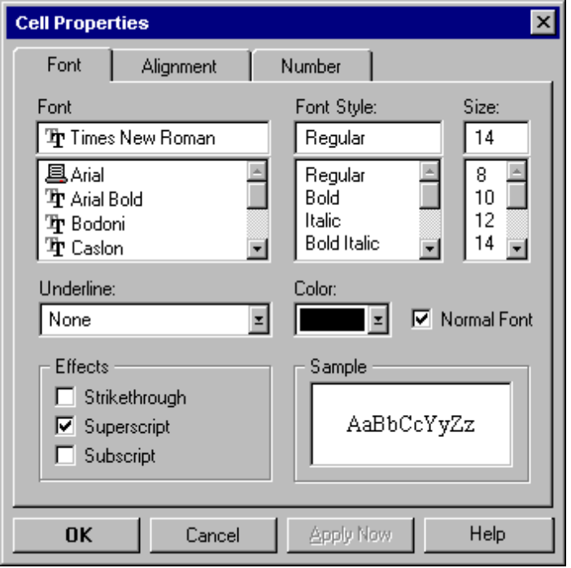

Figure 8.2 A Property Sheet.

You can also support access to the hierarchically related properties in the property sheet. For example, if the user selects a cell in a spreadsheet, you may want to provide access to its related row and column properties in the same property sheet. You can support this with additional tabbed pages, but access may be better facilitated using another control—such as a drop-down list—to switch between groups as shown in Figure 8.3.

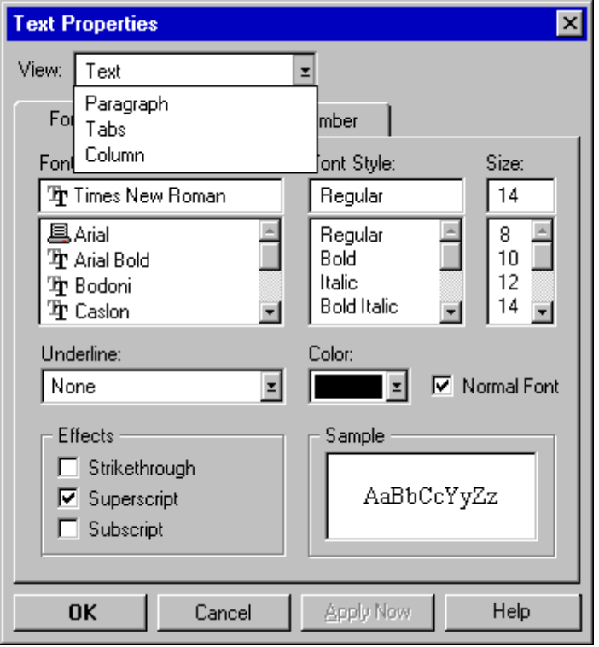

Figure 8.3 Using a Drop-down List for Hierarchical Navigation.

Property Sheet Transaction Commands
Property sheets typically allow the user to change the values for a properties and then apply those transactions. Property sheet transactions are applied using the following commands implemented as command buttons.

Command | Action
OK | Applies all pending changes and closes the property sheet window.
Apply | Applies all pending changes but leaves the property sheet window open.
Cancel | Terminates any pending changes (does not cancel or undo changes that have already been applied) and closes the property sheet window.

You can optionally support a Reset command for canceling pending changes without closing the window.
Note

Location of the transaction command buttons is very important. If you place the buttons outside of the property page (but still inside the window), then apply all property transactions applied as a set; that is, changes on all pages are applied (or canceled) at once. Switching pages in the sheet does not apply any properties.

If you place the transaction command buttons on (within) a property page, then commands apply to the transactions only on that page. In addition, if the user switches pages, any pending transactions are automatically applied.

If a property sheet applies changes by using transaction commands, then include a sample field that shows the effect of the change in the property sheet.

Where possible, make the values for properties found in property sheets transferable. You can support special transfer completion commands to enable copying only the properties of an object to another object.

For more details on the transfer operations, see Chapter 5, “General Interaction Techniques."

Closing a Property Sheet
If the user closes a property sheet window, it is similar to closing the content view of an object. If there are pending changes that have not been committed, prompt the user to apply or discard the changes through a message box as shown in in Figure 8.4.

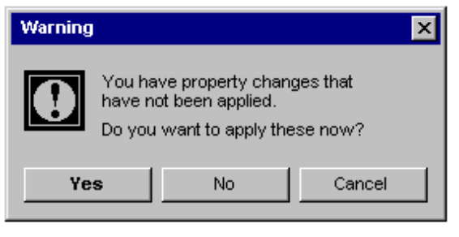

Figure 8.4 Prompting the User to Apply or Discard Pending Property Changes.
If the user chooses the Yes button and confirms the application of the properties, then the message box and the property sheet window are removed. If the user chooses the No button, they discard the pending changes and close the property sheet window. The user can also cancel the closing of the property sheet window by choosing the Cancel command.

Property Inspectors
A property inspector is different from a property sheet—a property sheet is a view of an object’s properties that is modal concerning the data for which it displays properties. However, a property inspector is a dynamic viewer or browser that reflects the properties of the current selection as shown in Figure 8.5.

illustration of a property inspector

Figure 8.5 A Property Inspector.
Transactions in property inspectors are also dynamic. A change of a property value is applied as soon as the user makes the change in the control reflecting that property value.

You can define property inspectors as toolbars or palette windows. You do not need to include all the user-accessible properties of an object in an inspector. Usually a property inspector is optimized for changing the most common or frequently changed properties for objects.

For more information about palette windows, see the section, “Palette Windows,” later in this chapter.

Properties of a Multiple Selection
When a user selects multiple objects and requests the properties for these items, the properties of all the objects are reflected in a single property sheet. Where the property values differ, those controls used to display and edit those property values reflect the mixed value appearance (sometimes referred to as indeterminate state).

For more information about mixed value appearance, see Chapter 13, “Visual Design.”

If access to individual objects in a selection set is important, you may want to include a control (for example, a list box or drop-down list) in the property window for switching between the properties of the objects in the set.

Properties of a Heterogeneous Selection
When a multiple selection includes different types of objects, the resulting property sheet includes the intersection of properties between the objects. However, if the objects in a selection are treated as if they were of a single type, the property sheet includes properties only for that type. For example, if you select a text field that includes text and an embedded object, such as a circle, and in that context, an embedded circle is treated as a text element, then present only the text properties in the resulting property sheet.

Properties of Grouped Items
Do not equate a multiple selection with a grouped set of objects. A group is a stronger relationship than a simple selection, because the aggregate resulting from the grouping can be considered an object itself, potentially with its own properties and operations. Therefore, if the user requests the properties of a grouped set of items, display the properties of the group or composite object. The properties of its individual members may or may not be included, depending on what is most appropriate.

Dialog Boxes
A dialog box provides an exchange of information or dialogue between the user and your software. Use a dialog box to gather additional information from the user — information that may be required to execute a particular command or task. As a result, dialog boxes typically contain only controls.

Because dialog boxes generally appear after choosing a particular menu item or command button, the set the title text to be the name of the associated command for the window; for example, for a Print command on the File menu, the title text should be Print, not Print... or File Print.

Layout
Orient controls in dialog boxes in the way people read information. In countries where roman alphabets are used, this means left to right, top to bottom. Locate the primary field with which the user interacts as close to the upper-left corner as possible. The same is true for orienting controls within groups in the dialog box.

Lay out the major command buttons either stacked along the upper-right border of the dialog box or lined up across the bottom of the dialog box. The most important button — typically the default command — should be the first button in the set. If you use the OK and Cancel buttons, group them together. If you include a Help button, make it the last button in the set. You can use other arrangements if there is a compelling reason, such as a natural mapping relationship. For example, it makes sense to place buttons labeled North, South, East, and West in a compass-like layout.

For more information about layout and spacing, see Chapter 13, “Visual Design.”

Shortcuts in Dialog Boxes
Optionally, you can use double-clicking on a single selection control, such as an option button or single selection list, to set or select the option and execute the default button of the dialog box.

Common Dialog Box Interfaces
The system provides prebuilt interfaces for many common operations. Use these interfaces where appropriate. They can save you time while providing a high degree of consistency.

These interfaces have been revised from the ones provided in previous releases.
Note

Open Dialog Box
The Open dialog box (shown in Figure 8.6) allows the user to browse the file system, including direct browsing of the network, and includes controls to open a specified file.

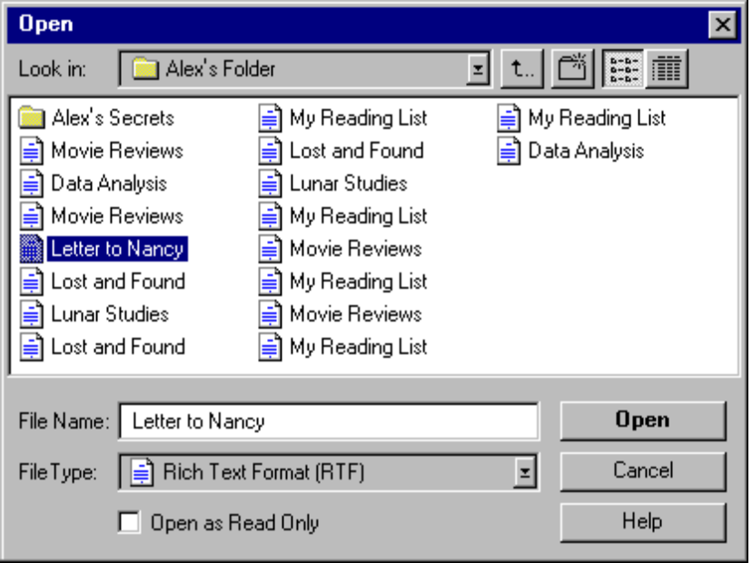

Figure 8.6 The Open Dialog Box.
The dialog box automatically handles the display of long filenames and file links, direct manipulation transfers (for example, drag and drop), and access to an icon’s pop-up menus.

If you open a file link, the resulting window is that of the object to which the link refers. In other words, the effect is the same as if the user directly opened the original file. Therefore, display the name of the original file, not the name of the file link. Similarly, when saving the file, the changes are saved back to the original file.

Save Dialog Box
The Save dialog box (shown in Figure 8.7) is designed to save a file using a particular name, location, and format. Display this dialog box when the user chooses the Save command and a filename has not been supplied or confirmed by the user. You use this same dialog box for a Save As command by changing the title bar text to Save As.

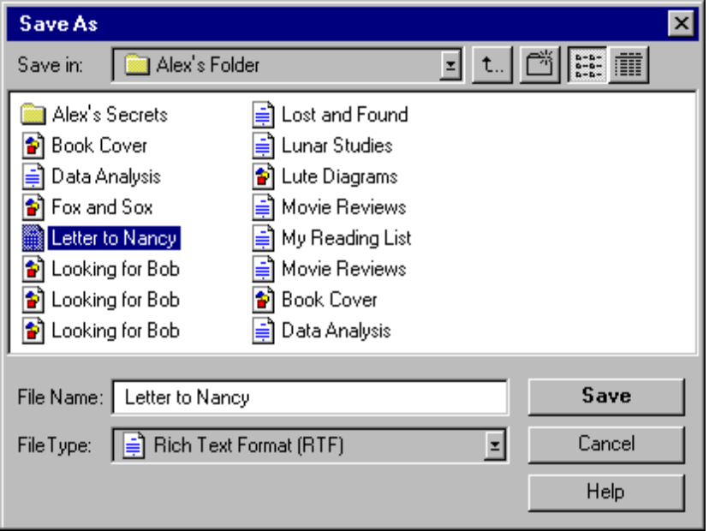

Figure 8.7 The Save Dialog Box.
This dialog box is similar to the Open dialog box except that the File Type field lists the possible formats for the target file. The File Type field replaces Files of Type—the type filter field . The Open dialog box also provides navigational controls that allow the user to browse the file system.

Find and Replace Dialog Boxes
The Find and Replace dialog boxes provide controls that search for a text string specified by the user and optionally replace it with a second text string specified by the user. These dialog boxes are shown in Figure 8.8.

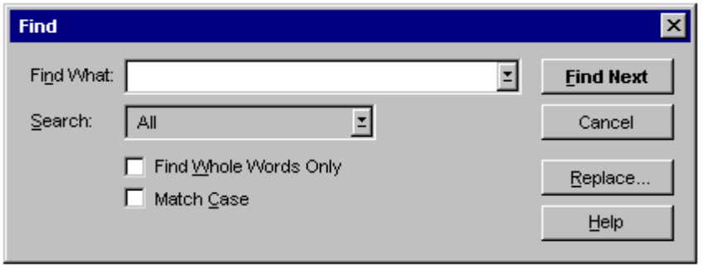

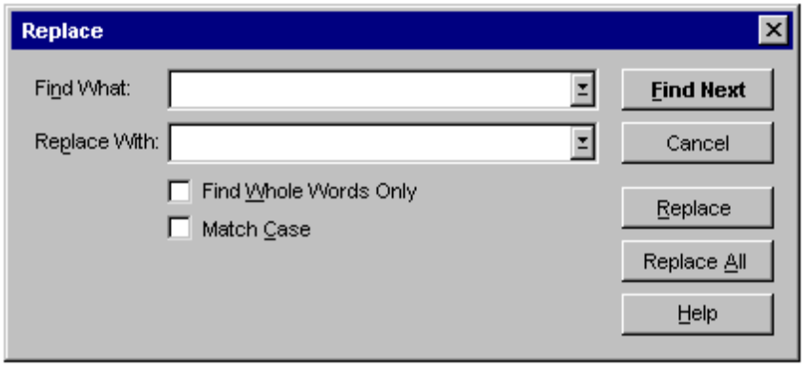

Figure 8.8 The Find and Replace Dialog Boxes.

Print Dialog Box
The Print dialog box (shown in Figure 8.9) allows the user to select what to print, the number of copies to print, and the collation sequence for printing. It also allows the user to choose a printer and provides a command button that provides shortcut access to that printer's properties.

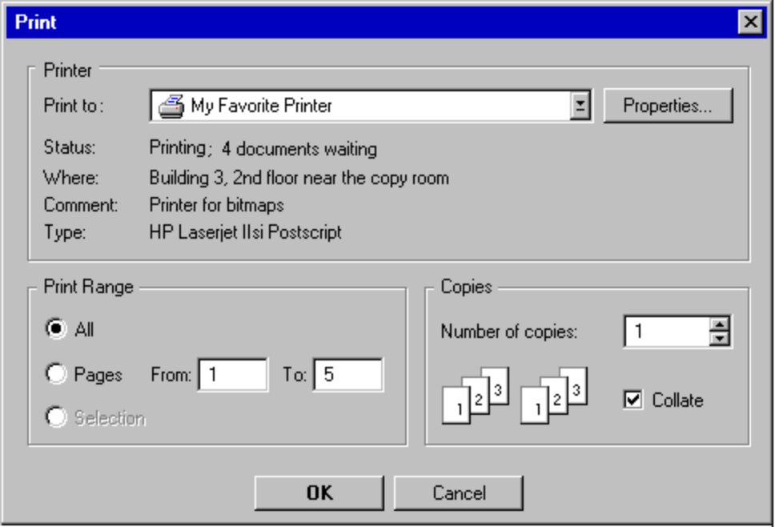

Figure 8.9 The Print Dialog Box.

Print Setup Dialog Box
The Print Setup dialog box displays the list of available printers and provides controls for selecting a printer as well as setting paper orientation, size, and source, and other printer properties. Figure 8.10 shows this dialog box.

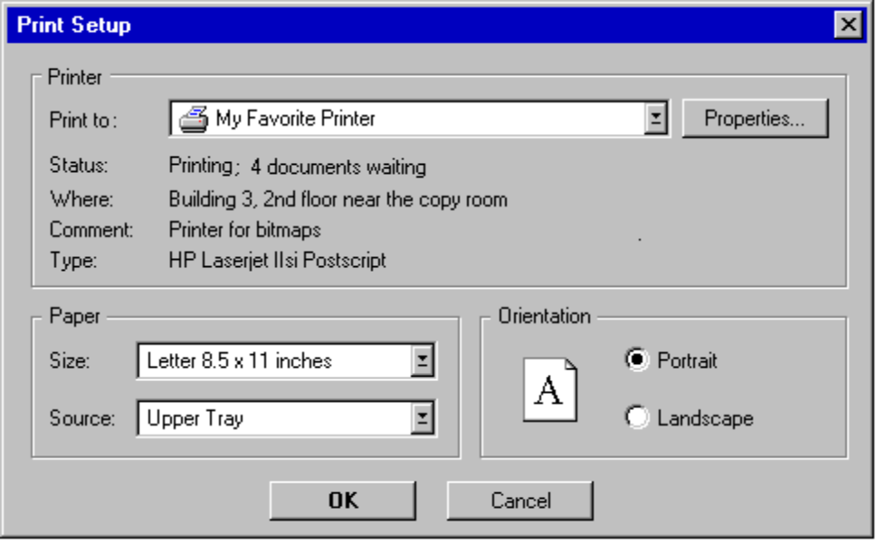

Figure 8.10 The Print Setup Dialog Box.

This dialog box provides compatibility with applications designed for Windows 3.1. Users access these properties through the property sheet of the appropriate printer, rather than from an application. Therefore, this dialog box is not recommended for applications following the guidelines in this book.
Note

Page Setup Dialog Box
The Page Setup dialog box provides controls for specifying properties about the page elements and layout. You can use it either as a dialog box, as shown in Figure 8.11, or as a property page in a property sheet window.

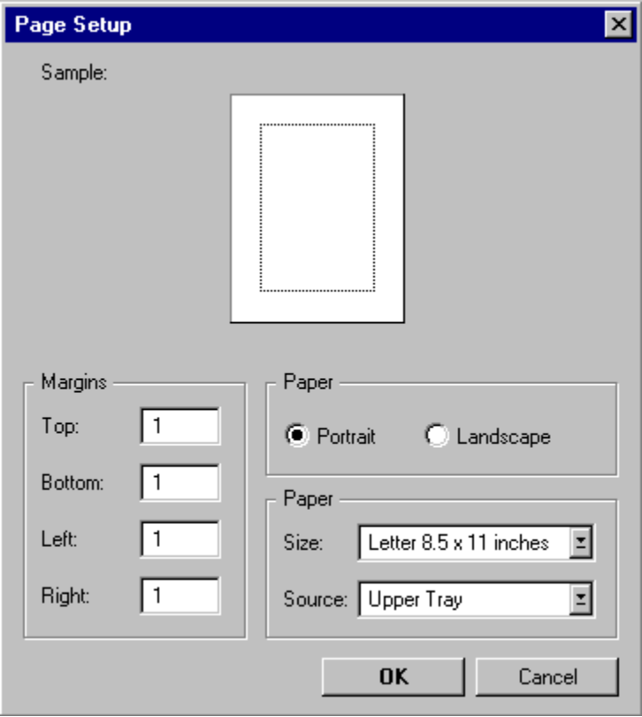

Figure 8.11 Page Setup Interface Used as a Dialog Box.
In this context, page orientation refers to the orientation of the page and not the printer which may also have these properties. Generally, the page’s properties override those set by the printer, but only for the printing of that page (or document).

Font Dialog Box
You can use the Font dialog box to display the font properties of a selection of text. Figure 8.12 shows the Font dialog box.

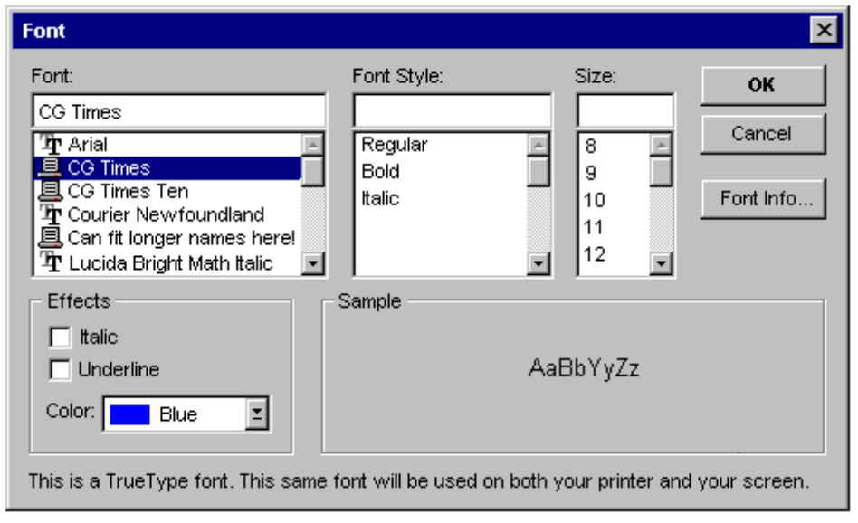

Figure 8.12 The Font Dialog Box.

Color Dialog Box
The Color dialog box provides controls for selecting the color property of a particular object.

Palette Windows
Palette windows are modeless secondary windows you can use to present a set of controls. For example, when toolbars appear in their own window, they appear in a palette window. Palette windows are also distinguished by their visual appearance. The height of the title bar for a palette window is shorter, but it still includes only a Close button in the title area as shown in 8.13.

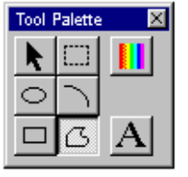

Figure 8.13 A Palette Window.
Make the title text for a palette window the name of the command that displays the window or the name of the toolbar it represents, optionally followed by the word “Palette”. Display the title text in the same font used in other windows, but in a smaller size to fit within the shorter title bar. For easier readability, do not make the title text bold.

For more information about the font specifications to use in the title bar of a palette window, see Chapter 13, "Visual Design."

Define palette windows as a fixed size, or more typically, sizable by the user. Two visual cues indicate when the window is sizable: changing the pointer image to the size pointer, and placing a Size command in the window’s pop-up menu. Preserve the window’s size and position so the window can be restored, if it or its associated primary window is closed.

Like other windows, the title bar, the Close button, and the border areas provide an access point for the window’s pop-up menu. Commands on a palette window’s pop-up menu typically include Close, Move, Size, Always On Top, and Properties as shown in Figure 8.14.

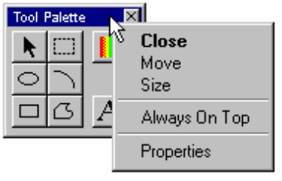

Figure 8.14 A Pop-up Menu for a Palette Window.
Including the Always On Top command (or property in the window’s property sheet) allows the palette window to always stay at the top of the Z-order of the window set of which it is a part. Setting this attribute places it at the top of other windows that are part of its related set. Turning off this option keeps the palette window within its set of related windows, but allows the user to have other windows of the set appear on top of the palette window. In this case, keep the palette window on top of the primary window of a set. This feature allows the user to configure preferred access to the palette window.

You can include a Properties command on the palette window’s pop-up menu to provide an interface for allowing the user to edit properties of the window, such as the Always On Top property or a means of customizing the content (controls) of the palette window.

You can dock palette windows, especially when they are used as the windowed presentation of toolbar. For more information about the docking behavior, see Chapter 7, “Menus, Controls, and Toolbars.”

Message Boxes
A message box is a secondary window that informs the user about a particular situation. Use the title bar of message box to appropriately identify the context displaying the message—this is usually the name of the object. For example, if the message results from editing a document, the title text is the name of that document. If the message results from a non-document object, then use the application name. Providing an appropriate identifier for the message is particularly important in the Windows 95 multitasking environment, because message boxes may not always be the result of current user interaction.

Message Box Types
Each message box includes a graphical symbol that indicates what kind of message is being presented. Most messages can be classified in one of the following categories:

n Informational messages
n Warning messages
n Critical messages

The following table describes each message type and shows its associated symbol.

Table 8.1 Message Types and Associated Symbols
Symbol | Message Type | Description
 | Information | Provides information about the results of a command. Offers no user choices; the user acknowledges the message by clicking the OK button.
 | Warning | Alerts the user to a condition or situation that requires the user’s decision and input before proceeding, such as an impending action with potentially destructive, irreversible consequences. The message can be in the form of a question (for example, “Save changes to MyReport?”).
 | Critical | Informs the user of a serious problem that requires correction before work can continue.

Figure 8.15 shows examples of message boxes.

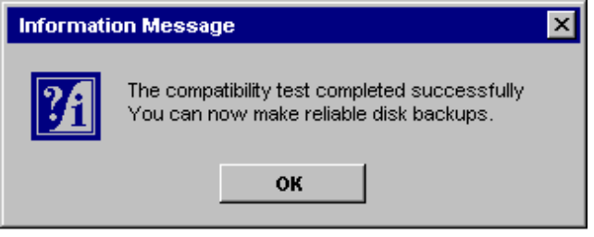

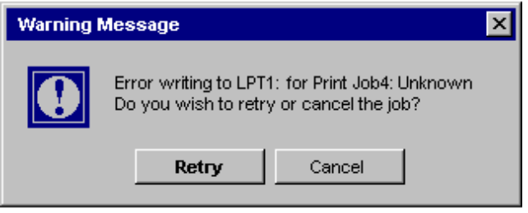

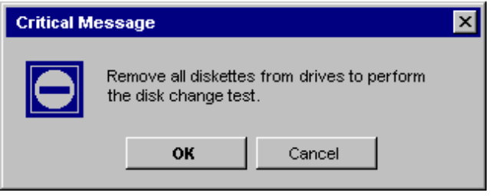

Figure 8.15 Informational, Warning, and Critical Message Boxes.
Because a message box disrupts the user’s current task, it is best to display a message box only when the task (application) associated with the message box is active. If it is not active, then the task with which the message box is associated uses its entry in the task bar to alert the user. Once the user activates the application, the message box can be displayed.

For more information about how an application uses the task bar to alert the user, see Chapter 10, “Integrating with the Shell.”

You can also use message boxes to provide information or status without requiring direct user interaction to dismiss them. For example, message boxes that provide a visual representation of the progress of a particular process automatically disappear when the process is complete as shown in Figure 8.16. In this situation, a message symbol is also not required.

illustration of a progress message box

Figure 8.16 A Progress Message Box.

Command Buttons in Message Boxes
Command buttons are usually the only controls in message boxes, and represent the appropriate responses or choices offered to the user. Designate the most frequent or least destructive option as the default command button.

If a message requires no choices to be made and requires only acknowledgement, the message box contains only an OK button (and optionally a Help button). If the message requires the user to make a choice, the window contains a command button for each option. The clearest way to present the choices is to state the message in the form of a question and provide a button for each response. When possible, phrase the the question to permit Yes or No answers, represented by Yes and No command buttons. If these choices are too ambiguous, consider command buttons labeled with the names of specific actions (for example, “Save” and “Delete”).

It is also acceptable to include command buttons in a message box that provide corrective action to the situation resonsible for the display of the message box. However, make the result of the button’s action very clear. For example, if the message box indicates that the user must switch to another application window to take corrective action, you may include a button that switches the user to that application window.

Some situations require offering the user not only a choice between performing or not performing an action, but an opportunity to cancel the process altogether. In such situations, use a Cancel button as shown in Figure 8.17.

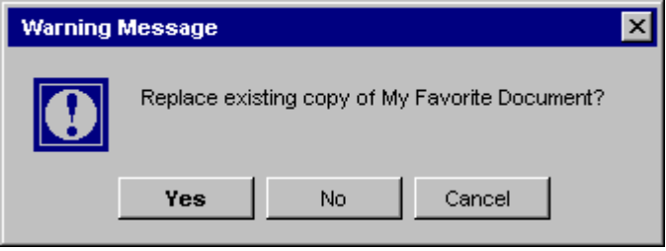

Figure 8.17 Appropriate Choices in a Message Box.

When using Cancel as a command button in a message box, remember that to users, Cancel implies restoring the state of the process or task that initiated the message. If you use Cancel to interrupt a process and the state cannot be restored, consider using Stop instead.
Note

Message Box Text
Messages are an important component to any software product. Messages that are too generic or poorly written frustrate users, increase support costs, and ultimately reflect on the quality of the product. Therefore, it is worthwhile to provide effective messages.

The message text you include in a message box should be clear, concise, and in terms that the user understands. This usually means no technical jargon or system-oriented information.

In addition, observe the following guidelines for your message text:

n For messages related to problem situations, state the problem and, if possible, its probable cause and what the user can do about it. For example, instead of “Insufficient disk space,” use “‘Sample Document’ could not be saved, because the disk is full. Try saving onto another disk or freeing up space on this disk.”
n Avoid phrasing that blames the user or implies user error. For example, use “Cannot find <filename>” instead of “Filename error.” Avoid the word “error” altogether.
n Make messages as unique and specific as possible. No more than two or three problems should map to a single message. For example, there may be several reasons why a file cannot be opened. Provide a specific message for each reason.
n For support purposes, you may want to include a message identification number for each message. To avoid interrupting the user’s ability to quickly read a message, it is best to place such a designation at the end of the message text.
n Avoid relying on default system-supplied messages (such as MS-DOS extended error messages and Kernel INT 24 messages) and instead, wherever possible, supply your own unique and specific messages.
n Limit the message to two or three lines. If further explanation is necessary, provide this through a command button that opens a Help window.

Pop-up Windows
You can use pop-up windows as a means of displaying additional information when an abbreviated form of the information is the main presentation. For example, you can use a pop-up window when an entire path cannot be presented and must be abbreviated — the pop-up window displays the full path. They are often used to provide contextual Help information as shown in Figure 8.18.

illustration
of a help pop-up
window in context

Figure 8.18 A Contextual Help Pop-up Window.
Tooltips are another form of contextual Help information. They provide the name for a control in toolbars. The lens control is another example of the use of a pop-up window.

For more information on the use of pop-up windows for contextual Help information, see Chapter 12, "User Assistance."

How pop-up windows are displayed depends on their use, but the typical means is by the user either pointing or clicking with mouse button 1 (for pen, proximity and tap), or an explicit command. If you use pointing, display the pop-up window using the system time-out metric, SM_TIMEOUT; that is, the pop-up window is displayed when the pointer remains at the same location until the time-out elapses. Also, use the time-out to determine when to remove the pop-up window.

If you use clicking to display a pop-up window, change the pointer as feedback to the user indicating that the pop-up window exists and requires a click. Usually, the pointing-hand cursor is the best to use. From the keyboard, use the Select key (spacebar) to open and close the window.

When you use an explicit command to display a pop-up menu — for example, a command on a pop-up menu — the pop-up window is also immediately displayed. With either of these methods, clicking a second time dismisses the window.

